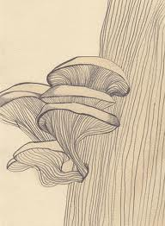
Kingdoms

These sheets contain the names of the 5 kingdoms of living things. For each kingdom there are 2 or 3 descriptions and 1 or more pictures.
Cut out the titles, descriptions and pictures and place them in a table like the one below in your book.

Kingdom
Descroptions
Picture

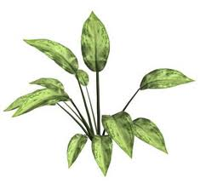
Animals
Plants
Monera (Bacteria)
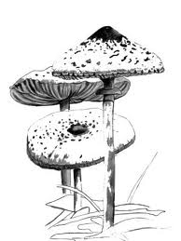
Fungi
Protists

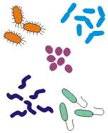
- Consumers
- Producers
- Decomposers
- Decomposers
- Some producers, some consumers
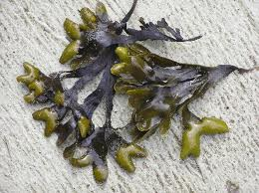
- Cell wall
- Cell wall
- No nucleus
- Made of many cells
- Made of many cells
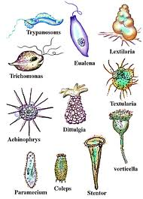
- May be single cellular or multi cellular
- May be single cellular or multi cellular
- No cell wall
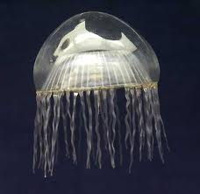
- Contains all the organisms that do not fit into other Kingdoms

